Assignment: Parallel Zombie Outbreak Simulation in C++ with OpenMP
Objective
In this assignment, you will implement a parallel grid-based zombie outbreak simulation in C++ using OpenMP. The goal is to practice parallel loops, synchronization, workload decomposition, and performance measurement.
You will simulate the spread of infection across a large 2D population grid. Each cell represents one location and may contain:
0 = empty
1 = human
2 = zombie
At each simulation step, every zombie attempts to infect neighboring humans in the four cardinal directions, but they cannot infect empty cells:
up, down, left, right (Please look at my animation https://htmlpreview.github.io/?https://raw.githubusercontent.com/xiaoyuansuo51-webster/teaching-PDC-HPC/refs/heads/main/ZombieAttach_XSUO.html?token=GHSAT0AAAAAAD2SBJBLIYTMLLBL22RXLLNK2PZMS5A)
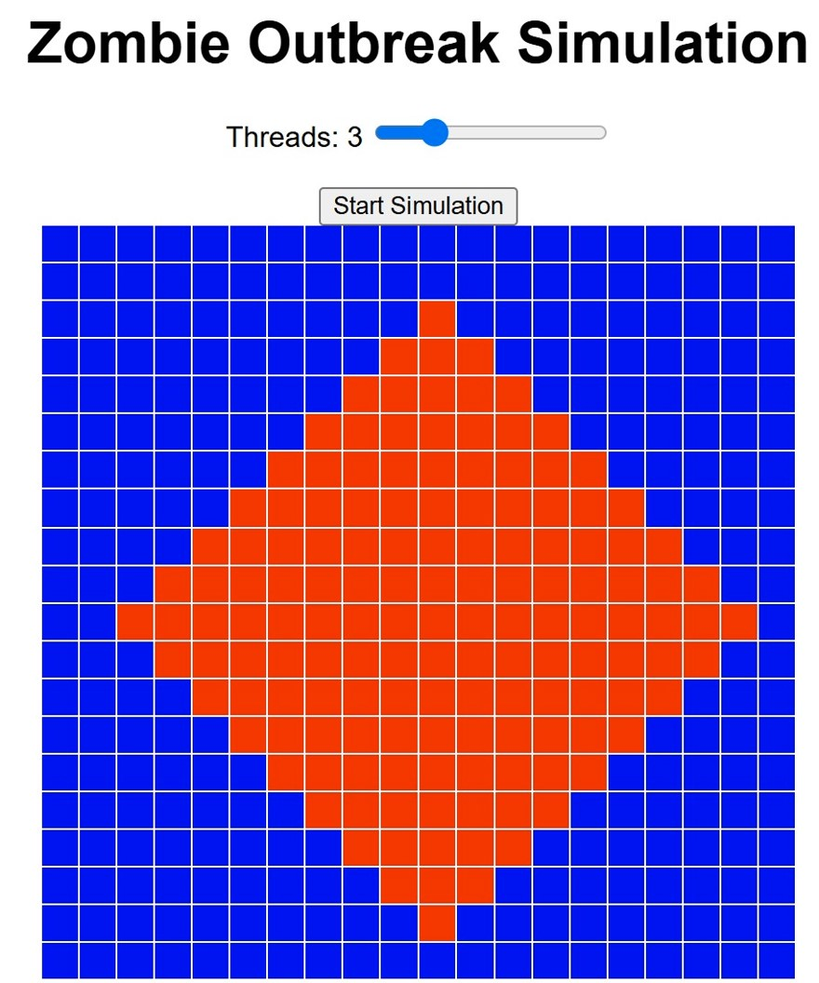
The simulation continues until there are no humans left or until a maximum number of steps is reached.

1. Grid Initialization
There are input files in the same folder (Week 13), the files all contain a single 2D grid, for example:
1000 x 1000
The grid should be initialized randomly with:
60-70% humans
29-39% empty cells
1% zombies
There are different distributions, but it will include many humans and multiple zombies.

2. Time-Step Simulation
The simulation must run in discrete time steps.
At each step:
1. Scan the grid.
2. For every zombie, check its four neighbors.
3. If a neighbor is human, it becomes infected.
4. Update the grid for the next time step.
Important: you should use two grids:
currentGrid
nextGrid
Do not update the same grid directly while scanning it. This avoids race conditions and makes the simulation logically correct.

3. OpenMP Parallelization
You must parallelize the main grid traversal using OpenMP.
#pragma omp parallel for collapse(2)
Your program should also count the number of remaining humans using an OpenMP reduction:
#pragma omp parallel for reduction(+:humanCount)

4. Race Condition Avoidance
Your program must explain how it avoids race conditions.
A good solution should use one of these approaches:
currentGrid is read-only during each step
nextGrid stores updates
Then after each step:
currentGrid.swap(nextGrid);

5. Termination Condition
The simulation should stop when either:
humanCount == 0
or
step == maxSteps

6. Performance Experiment
YOu must run the program with different thread counts:
1 thread
2 threads
4 threads
8 threads
They should record runtime using:
omp_get_wtime()
Speedup should be calculated as:
Speedup = runtime with 1 thread / runtime with N threads

Required Output
The program should print:
Grid size: 1000 x 1000
Initial humans: 700000
Initial zombies: 10000
Threads used: 4
Total steps: 35
Remaining humans: 0
Runtime: 0.842 seconds
Speedup: 2.73

Submission Requirements
You should submit:
1. Completed C++ source file.
2. A short paragraph explaining:
- how the grid was divided among threads,
- how OpenMP was used,
- how race conditions were avoided,
- whether the parallel version was faster.
3. A small runtime table comparing 1, 2, 4, and 8 threads.

Grading
Category | Points | Description
Read files (not parallelized) | 10 | Correctly reads a large 2D grid with humans, zombies, and empty cells
Zombie spread logic | 20 | Correctly infects neighboring humans at each time step
Double-buffered update | 15 | Uses currentGrid and nextGrid to avoid incorrect updates
OpenMP parallelization | 20 | Correctly uses OpenMP parallel loops
Reduction/counting logic | 10 | Correctly counts remaining humans in parallel
Termination condition | 10 | Stops when no humans remain or max steps is reached
Performance experiment | 10 | Compares runtime using multiple thread counts
Code quality and style | 5 | Code is readable, organized, and followed our style guidline

